**Year 11 General Human Biology**

**Task 6: Supervised written – Immune System (10%)**

RESULT

/ 40

**Task 6**

**TYPE:** Supervised Written

**CONTENT:** Immune System

**WEIGHTING:** 10%

**Student Name: MARKING KEY**

**Due date: ___ / ___ / ______**

**Teacher:** Mrs Cunningham

**CONDITIONS:**

Must be completed under test conditions in class. This task will be competed individually.

50 minutes allocated

40 Marks

**TASK DETAILS:**

This task contains **four** questions with a number of parts to assess the student’s understanding of the content from the science understanding topics cell reproduction, reproductive systems and pregnancy.

Notes/reference materials may not be used during this task.

This task contains a number of question types. You could be required to:

* provide single word, sentence or short paragraph responses
* construct, use, interpret or analyse secondary data, graphs, tables or diagrams
* provide responses making connections, drawing conclusions, constructing arguments, analysing and/or evaluating information.

Your responses may incorporate labelled diagrams or tables with explanatory notes.

**Answer all questions in the spaces provided. (TOTAL 40 marks)**

Question 1 (TOTAL 18 marks)

In hospitals, there is always a risk that doctors moving from patient to patient may accidently transfer infections and pathogens. To guard against this, it is standard practice for doctors to wash their hands between seeing patients.

1. Define the term ‘pathogen’. (1 mark)

**A disease-causing organism**

A hospital decided to investigate whether using disposable gloves, as well as washing hands would provide more protection to patients. The hospital made it compulsory for doctors to wash their hands and wear gloves when moving between patients.

To determine the effectiveness of this policy, the rate of patients contracting infections while in this hospital was compared to that of patients at a hospital where doctors only washed their hands.

The results obtained from the investigation are shown in the able below.

|  |  |  |
| --- | --- | --- |
|  | **Procedure** | **Infection rate (number/1000 patients)** |
| Hospital 1 | Washing hand and wearing gloves | 9 |
| Hospital 2 | Washing hands only | 12 |

1. On the grid provided below, graph the data presented in the table above. (5 marks)

**Title including both independent and dependent variables (1)**

**Axes labelled correctly, including units on Y axis (1)**

**Even scale Y axis (1)**

**Data plotted accurately (1)**

**Columns drawn correctly, including gap between Y axis and first column and between columns (1)**

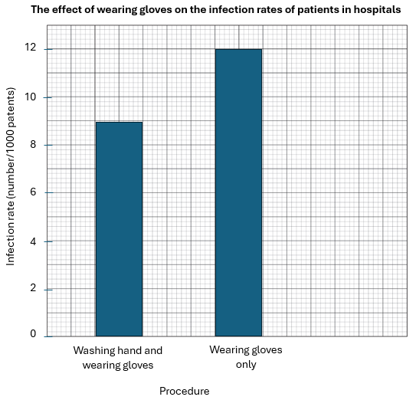

1. Propose a hypothesis the hospital scientists were investigating. (2 marks)

**Statement of the relationship between the independent and dependent variables (1)**

**Statement is testable (1)**

**Accept other relevant answers: Washing hands and wearing disposable gloves reduces the rate of infection transfer between hospital patients.**

1. Identify the independent and dependent variables in this investigation. (2 marks)

Independent variable

**wearing disposable gloves (1)**

Dependent variable

**infection rate (1)**

1. State **two** variables that should be controlled in this investigation. (2 marks)

**States any two variables to be controlled (2 x 1 mark)**

* **types of gloves being worn**
* **type of detergent/soap being used to wash hands**
* **length of time washing hands**
* **types of patients/patient illness**

1. Write a conclusion for this investigation. Justify your answer. (2 marks)

**Wearing disposable gloves reduces the transfer of infection between hospital patients.**

**Accept any other relevant answers.**

Question 2 (TOTAL 9 marks)

The body’s first line of defence provides non-specific barriers to the entry of pathogens.

1. Describe one way each of the following structures protect the body against the entry of pathogens. (4 marks)

|  |  |
| --- | --- |
| Structure | How it protects against the entry of pathogens |
| Skin | **impervious barrier (1) to entry of pathogens (1)** |
| Nasal cavity | **hairs/cilia trap pathogens/push pathogens out (1)**  **mucous traps pathogens (1)** |

**Describes any one method for each barrier ( 2 x 2 marks)**

**Accept any other relevant answers.**

The body’s second line of defence provides a non-specific response to pathogens that have entered the body.

Mrs Jones accidentally pricked her right thumb when trimming a rose plant. The injured area became swollen, red and slightly tender to touch.

1. Name the type of response Mrs Jones has had to her injury. (1 mark)

**Inflammatory response/inflammation (1)**

1. Explain why the injured tissue becomes swollen and red. (4 marks)

**(mast) cells release histamine (1)**

**capillaries dilate (1)**

**capillaries become leaky (1)**

**increased blood flow to area (1)**

The body’s third line of defence is a specific response to pathogens. It kills or inactivates the pathogen and provides immunity to future infections.

Question 3 (TOTAL 13 marks)

A child was immunised against measles at 1 year old and again at 4 years old.

1. Name the cells that were stimulated to produce antibodies after the first injection. (1 mark)

**B cells (1)**

1. Name the type of cell present at the beginning of the second injection but not at the beginning of the first injection. (1 mark)

**Memory cells (1)**

1. Using the information from the graph, explain difference between the responses to the first and second injection. (5 marks)

**response after first injection take longer (1)**

**because antibodies take time to be produced (1)**

**second exposure peaks at a higher level/more antibodies are produced after second exposure (1)**

**due to memory cells (1)**

**levels of anitbodies are maintain longer after second exposure (1)**

Immunity can be classed as passive or active.

1. Contrast active and passive immunity. (2 marks)

**Passive – immunity acquired from someone or something else (1)**

**Active – immunity developed after being exposed to an infection or vaccine/an antigen (1)**

1. Compare the different types of passive and active immunity. (4 marks)

|  |  |  |
| --- | --- | --- |
|  | Natural | Artificial |
| Active | **Antibodies produced after exposure to the pathogen/disease/ infection/antigen (1)** | **Antibodies produced after vaccination containing (1)** |
| Passive | **Antibodies passed from mother to baby through the placenta and breast milk (1)** | **Antibodies injected into bloodstream (1)** |

**END OF ASSESSMENT**